VISVESVARAYA TECHNOLOGICAL UNIVERSITY
“JnanaSangama”, Belgaum -590014, Karnataka.

LAB REPORT
On

ANALYSIS AND DESIGN OF ALGORITHMS (23CS4PCADA)

Submitted by

SHASHANK SHANTHARAM NAYAK (1BM23CS313)

in partial fulfillment for the award of the degree of
BACHELOR OF ENGINEERING
in
COMPUTER SCIENCE AND ENGINEERING



B.M.S. COLLEGE OF ENGINEERING
(Autonomous Institution under VTU)
BENGALURU-560019
February-May 2025

B. M. S. College of Engineering,
Bull Temple Road, Bangalore 560019
(Affiliated To Visvesvaraya Technological University, Belgaum)
Department of Computer Science and Engineering



This is to certify that the Lab work entitled “ANALYSIS AND DESIGN OF ALGORITHMS” carried out by SHASHANK SHANTHARAM NAYAK (1BM23CS313), who is bonafide student of B. M. S. College of Engineering. It is in partial fulfillment for the award of Bachelor of Engineering in Computer Science and Engineering of the Visvesvaraya Technological University, Belgaum during the year 2024-25. The Lab report has been approved as it satisfies the academic requirements in respect of Analysis and Design of Algorithms Lab - (23CS4PCADA) work prescribed for the said degree.

Dr. Sarala D V Dr. Kavitha Sooda
Assistant Professor Professor and Head
Department of CSE Department of CSE
BMSCE, Bengaluru BMSCE, Bengaluru

Index Sheet
Sl.  No. | Experiment Title | Page No.
1 | Write program to obtain the Topological ordering of vertices in a given digraph.  LeetCode Program related to Topological sorting | 5
2 | Implement Johnson Trotter algorithm to generate permutations. | 10
3 | Sort a given set of N integer elements using Merge Sort technique and compute its time taken. Run the program for different values of N and record the time taken to sort.  LeetCode Program related to sorting. | 12
4 | Sort a given set of N integer elements using Quick Sort technique and compute its time taken.  LeetCode Program related to sorting. | 19
5 | Sort a given set of N integer elements using Heap Sort technique and compute its time taken. | 22
6 | Implement 0/1 Knapsack problem using dynamic programming.  LeetCode Program related to Knapsack problem or Dynamic Programming. | 25
7 | Implement All Pair Shortest paths problem using Floyd’s algorithm.  LeetCode Program related to shortest distance calculation. | 29
8 | Find Minimum Cost Spanning Tree of a given undirected graph using Prim’s algorithm.  Find Minimum Cost Spanning Tree of a given undirected graph using Kruskal’s algorithm. | 36
9 | Implement Fractional Knapsack using Greedy technique.  LeetCode Program related to Greedy Technique algorithms. | 43
10 | From a given vertex in a weighted connected graph, find shortest paths to other vertices using Dijkstra’s algorithm. | 49
11 | Implement “N-Queens Problem” using Backtracking. | 52

Course outcomes:
CO1 | Analyze time complexity of Recursive and Non-recursive algorithms using asymptotic notations.
CO2 | Apply various design techniques for the given problem.
CO3 | Apply the knowledge of complexity classes P, NP, and NP-Complete and prove certain problems are NP-Complete
CO4 | Design efficient algorithms and conduct practical experiments to solve problems.

Lab program 1:
Write program to obtain the Topological ordering of vertices in a given digraph.

Code:
//C program to implement topological sort using DFS
#include <stdio.h>
int n, a[10][10], res[10], s[10], top = 0;
void dfs(int, int, int[][10]);
void dfs_top(int, int[][10]);
int main()
{
printf("Enter the no. of nodes:");
scanf("%d", &n);
int i, j;
for (i = 0; i < n; i++) {
for (j = 0; j < n; j++) {
scanf("%d", &a[i][j]);
}
}
dfs_top(n, a);
printf("Solution: ");
for (i = n - 1; i >= 0; i--) {
printf("%d ", res[i]);
}
printf("\n");
return 0;
}
void dfs_top(int n, int a[][10]) {
int i;
for (i = 0; i < n; i++) {
s[i] = 0;
}
for (i = 0; i < n; i++) {
if (s[i] == 0) {
dfs(i, n, a);
}
}
}
void dfs(int j, int n, int a[][10]) {
s[j] = 1;
int i;
for (i = 0; i < n; i++) {
if (a[j][i] == 1 && s[i] == 0) {
dfs(i, n, a);
}
}
res[top++] = j;
}
Output:
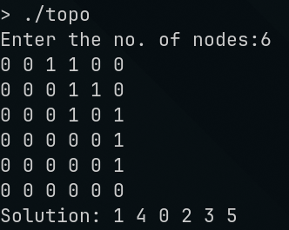

LeetCode Program related to Topological sorting
COURSE SCHEDULE II
/**
* Note: The returned array must be malloced, assume caller calls free().
*/
int* findOrder(int numCourses, int** prerequisites, int prerequisitesSize, int* prerequisitesColSize, int* returnSize) {
// Step 1: Initialize adjacency list and in-degree array
int* inDegree = (int*)calloc(numCourses, sizeof(int));
int** adjList = (int**)malloc(numCourses * sizeof(int*));
int* adjListSizes = (int*)calloc(numCourses, sizeof(int));

// Initialize adjacency list
for (int i = 0; i < numCourses; ++i) {
adjList[i] = NULL;
}

// Fill adjacency list and in-degree array
for (int i = 0; i < prerequisitesSize; ++i) {
int course = prerequisites[i][0];
int prerequisite = prerequisites[i][1];

adjList[prerequisite] = (int*)realloc(adjList[prerequisite], (adjListSizes[prerequisite] + 1) * sizeof(int));
adjList[prerequisite][adjListSizes[prerequisite]++] = course;
inDegree[course]++;
}

// Step 2: Initialize queue for courses with no prerequisites
int* queue = (int*)malloc(numCourses * sizeof(int));
int front = 0, rear = 0;

for (int i = 0; i < numCourses; ++i) {
if (inDegree[i] == 0) {
queue[rear++] = i;
}
}

// Step 3: Perform BFS and generate topological ordering
int* order = (int*)malloc(numCourses * sizeof(int));
int orderIndex = 0;

while (front < rear) {
int course = queue[front++];
order[orderIndex++] = course;

for (int i = 0; i < adjListSizes[course]; ++i) {
int nextCourse = adjList[course][i];
if (--inDegree[nextCourse] == 0) {
queue[rear++] = nextCourse;
}
}
}

// Step 4: Check if topological sort includes all courses
if (orderIndex != numCourses) {
*returnSize = 0;
free(order);
order = NULL;
} else {
*returnSize = orderIndex;
}

// Free memory
for (int i = 0; i < numCourses; ++i) {
free(adjList[i]);
}
free(adjList);
free(adjListSizes);
free(inDegree);
free(queue);

return order;
}
Output:
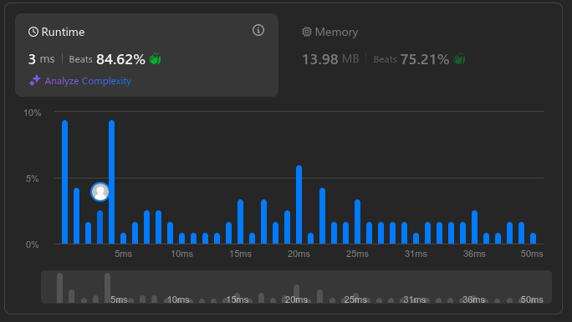

Lab program 2:
Implement Johnson Trotter algorithm to generate permutations.

Code:
#include <stdio.h>
#include <stdlib.h>
void swap(int* a, int* b) {
int temp = *a;
*a = *b;
*b = temp;
}
void generatePermutations(int arr[], int start, int end) {
if (start == end) {
for (int i = 0; i <= end; i++) {
printf("%d ", arr[i]);
}
printf("\n");
} else {
for (int i = start; i <= end; i++) {
swap(&arr[start], &arr[i]);
generatePermutations(arr, start + 1, end);
swap(&arr[start], &arr[i]); // backtrack
}
}
}
int main() {
int n;
printf("Enter the number of elements: ");
scanf("%d", &n);

int* arr = (int*)malloc(n * sizeof(int));
printf("Enter the elements: ");
for (int i = 0; i < n; i++) {
scanf("%d", &arr[i]);
}
generatePermutations(arr, 0, n - 1);
free(arr);
return 0;
}

Output:
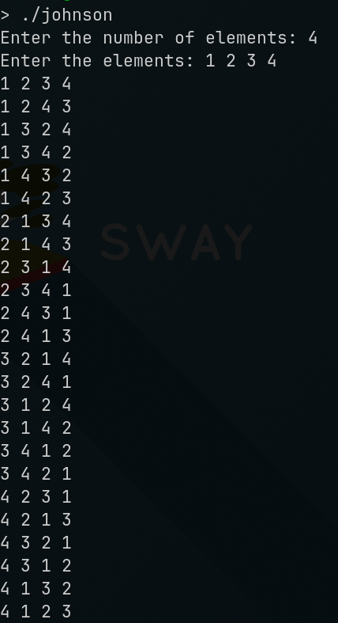
Lab program 3:
Sort a given set of N integer elements using Merge Sort technique and compute its time taken. Run the program for different values of N and record the time taken to sort.

Code:
#include <stdio.h>
#include <stdlib.h>
#include <time.h>

void display(int* arr, int n) {
for(int i = 0; i < n; i++) {
printf("%d\t", arr[i]);
}
printf("\n");
}

void merge(int* arr, int low, int mid, int high) {
int left_size = mid - low + 1;
int right_size = high - mid;

int left[left_size];
int right[right_size];

for (int i = 0; i < left_size; i++) {
left[i] = arr[low + i];
}
for (int i = 0; i < right_size; i++) {
right[i] = arr[mid + 1 + i];
}

int i = 0, j = 0, k = low;
while (i < left_size && j < right_size) {
if (left[i] <= right[j]) {
arr[k] = left[i];
i++;
} else {
arr[k] = right[j];
j++;
}
k++;
}

while (i < left_size) {
arr[k] = left[i];
i++;
k++;
}

while (j < right_size) {
arr[k] = right[j];
j++;
k++;
}

}

void mergesort(int* arr, int low, int high) {
if (low < high) {
int mid = (low + high) / 2;

mergesort(arr, low, mid);
mergesort(arr, mid + 1, high);

merge(arr, low, mid, high);
}
}

void main()
{
int a[15000],n,i,j,ch,temp;
clock_t start,end;
while(1)
{
printf("\n1:For manual entry of N value and array elements");
printf("\n2:To display time taken for sorting number of elements N in the range 500 to 14500");
printf("\n3:To exit");
printf("\nEnter your choice:");
scanf("%d", &ch);
switch(ch)
{
case 1: printf("\nEnter the number of elements: ");
scanf("%d",&n);
printf("\nEnter array elements: ");
for(i=0;i<n;i++)
{
scanf("%d",&a[i]);
}
start=clock();
mergesort(a, 0, n-1);
end=clock();
printf("\nSorted array is: ");
for(i=0;i<n;i++)
printf("%d\t",a[i]);
printf("\n%d,%f",n, (((double)(end-start))/CLOCKS_PER_SEC));
break;
case 2: n=500;
while(n<=14500)
{
for(i=0;i<n;i++)
{
a[i]=n-i;
}
start=clock();
mergesort(a, 0, n-1);
//Dummy loop to create delay
for(j=0;j<500000;j++){ temp=38/600;}
end=clock();
printf("\n%d,%f",n, (((double)(end-start))/CLOCKS_PER_SEC));
n=n+1000;
}
break;
case 3: exit(0);
}
getchar();
}
}

Output:
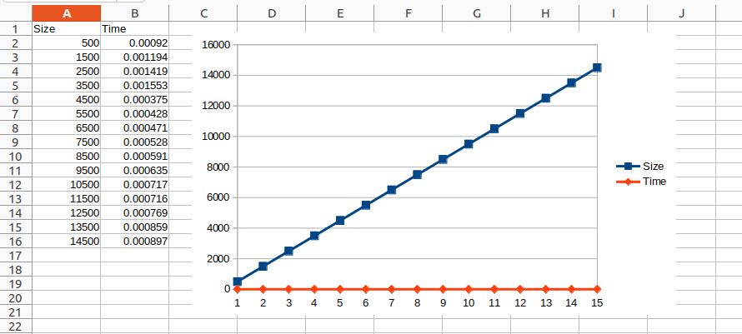

LeetCode Program related to sorting.
SORT COLORS
Code:
class Solution {
public void sortColors(int[] nums) {
int count0=0,count1=0,count2=0;
for(int num:nums){
switch(num){
case 0 -> count0++;
case 1 -> count1++;
case 2 -> count2++;
}
}
int ptr=0;
while(ptr<nums.length){
if(count0!=0){
nums[ptr]=0;
count0--;
}
else if(count1!=0){
nums[ptr]=1;
count1--;
}
else
{
nums[ptr]=2;
}
ptr++;
}
}
}
Output:
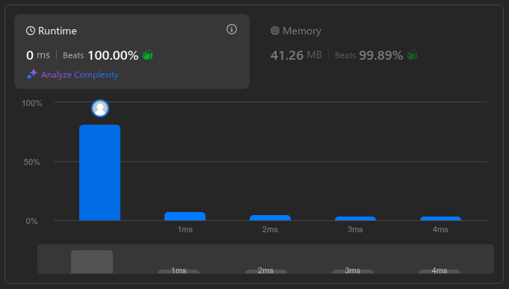

Lab Program 4:
Sort a given set of N integer elements using Quick Sort technique and compute its time taken.
Code:
#include <stdio.h>
#include <stdlib.h>
#include <stdbool.h>

void swap(int* a, int* b)
{
int temp = *a;
*a = *b;
*b = temp;
}

int partition(int* arr, int low, int high)
{
int i=low-1, j=low;
int x = arr[high];
for(;j < high;j++)
{
if(arr[j]<x)
{
i++;
swap(&arr[j],&arr[i]);
}
}
i++;
swap(&arr[i],&arr[high]);
return i;
}

void quicksort(int* arr, int low, int high)
{
if(low >= high)
return;
int mid = partition(arr, low, high);
quicksort(arr, low, mid-1);
quicksort(arr, mid+1, high);
}

void main()
{
int n;
printf("Enter n:");
scanf("%d",&n);
printf("Enter array elements:");
int arr[n];
for(int i=0;i<n;i++)
scanf("%d",&arr[i]);
quicksort(arr, 0, n-1);
printf("Sorted array:\n");
for(int i=0;i<n;i++)
printf("%d\t",arr[i]);
printf("\n");
}
Output:
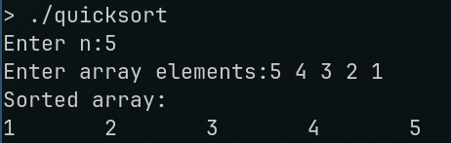

Lab Program 5:
Sort a given set of N integer elements using Heap Sort technique and compute its time taken.
Code:
#include <stdio.h>
#include <stdlib.h>

int left(int i){
return 2*i;
}

int right(int i){
return 2*i+1;
}

void maxHeapify(int* arr, int i, int size)
{
int largest;
int l = left(i);
int r = right(i);
if(l<size && arr[l]>arr[i])
largest = l;
else
largest = i;
if(r<size && arr[r]>arr[largest])
largest = r;

if(largest != i)
{
int temp = arr[i];
arr[i] = arr[largest];
arr[largest] = temp;
maxHeapify(arr, largest, size);
}
}

void build(int* arr, int n)
{
for(int i=n/2;i>=0;i--)
maxHeapify(arr, i, n);
}

void heapsort(int* arr, int n)
{
build(arr, n);
int size = n;
for(int i=n-1;i>=1;i--)
{
int temp = arr[0];
arr[0] = arr[i];
arr[i] = temp;
size--;
maxHeapify(arr, 0, size);
}
}

int main()
{
int n;
printf("Enter n:");
scanf("%d",&n);
int* a = (int*)malloc(n*sizeof(int));
printf("Enter elements:");
for(int i=0;i<n;i++)
scanf("%d",&a[i]);
heapsort(a, n);
printf("Heap:\n");
for(int i=0;i<n;i++)
printf("%d ",a[i]);
printf("\n");
}
Output:
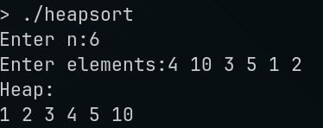

Lab Program 6:
Implement 0/1 Knapsack problem using dynamic programming.
Code:
#include<stdio.h>
int i,j,n,c,w[10],p[10],v[10][10];
void knapsack(int n,int w[10],int p[10],int c)
{
int max(int,int);
for(i=0;i<=n;i++)
{
for(j=0;j<=c;j++)
{
if(i==0||j==0)
v[i][j]=0;
else if(w[i]>j)
v[i][j]=v[i-1][j];
else
v[i][j]=max(v[i-1][j],(v[i-1][j-w[i]]+p[i]));

}
}
printf("\n\n Maximum Profit is : %d ",v[n][c]);
printf("\n\n\n Table : \n\n");
for(i=0;i<=n;i++)
{
for(j=0;j<=c;j++)
{
printf("\t%d",v[i][j]);
}
printf("\n");
}
}
int max(int a,int b)
{
return ((a>b)?a:b);
}
void main()
{
printf("\n Enter the no. of objects : ");
scanf("%d",&n);
printf("\n Enter the weights : ");
for(i=1;i<=n;i++)
{
scanf("%d",&w[i]);
}
printf("\n Enter the Profits : ");
for(i=1;i<=n;i++)
{
scanf("%d",&p[i]);
}
printf("\n Enter the capacity : ");
scanf("%d",&c);
knapsack(n,w,p,c);
}

Output:
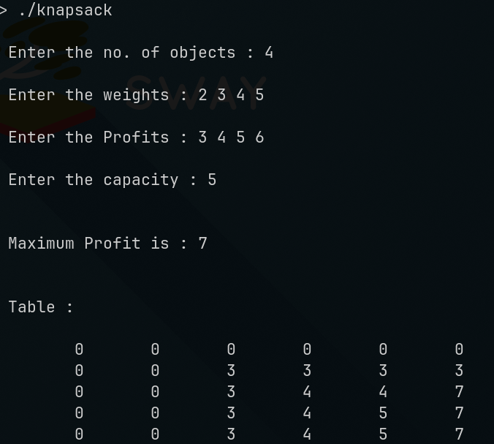

LeetCode Program related to Knapsack problem or Dynamic Programming.
MAXIMUM SUBARRAY
Code:
class Solution {
public int maxSubArray(int[] nums) {
int sum=0;
int best= Integer.MIN_VALUE;
for (int num: nums){
System.out.print(num+"\t");
sum=Math.max(num, sum+num);
System.out.print(sum+"\t");
best=Math.max(sum,best);
System.out.println(best+"\t");
}
return best;
}
}
Output:
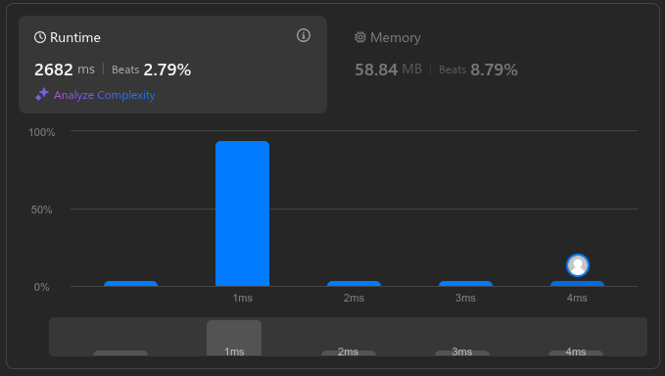

Lab Program 7:
Implement All Pair Shortest paths problem using Floyd’s algorithm.
Code:
#include <stdio.h>
#include <stdlib.h>

#define MAX 10

void floyd(int n, int edge[n][n])
{
int p[n][n];
for(int i=0;i<n;i++)
{
for(int j=0;j<n;j++)
{
p[i][j]=edge[i][j];
}
}
for(int k=0;k<n;k++)
{
for(int i=0;i<n;i++)
{
for(int j=0;j<n;j++)
{
if(p[i][j]>p[i][k]+p[k][j])
p[i][j]=p[i][k]+p[k][j];
}
}
}
for(int i=0;i<n;i++)
{
for(int j=0;j<n;j++)
{
printf("%d\t",p[i][j]);
}
printf("\n");
}
}

void main()
{
int n;
printf("Enter n:");
scanf("%d",&n);
int edge[n][n];
printf("Enter Adjacency Matrix:\n");
for(int i=0;i<n;i++)
{
for(int j=0;j<n;j++)
{
scanf("%d",&edge[i][j]);
}
}
floyd(n, edge);
}
Output:
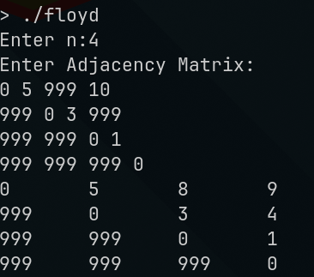

LeetCode Program related to shortest distance calculation.
NETWORK DELAY TIME
Code:
#define SOURCE times[i][0] - 1
#define DESTINATION times[i][1] - 1
#define WEIGHT times[i][2]
#define MAX 100001
#define MAXCOST 101

void init(int array[], int initializer, int n){
for(int i = 0; i < n; i++){
array[i] = initializer;
}
}

int **prepareSparse(int n, int **times, int timeSize, int* timesColSize){
int **matrix = (int **) malloc(sizeof(int *) * n);
for(int i = 0; i < n; i++){
matrix[i] = (int *) malloc(sizeof(int) * n);
init(matrix[i], MAX, n);
}

for(int i = 0; i < timeSize; i++){
matrix[SOURCE][DESTINATION] = WEIGHT;
}
return matrix;
}

int getMin(int cost[], int visited[], int n){
int index = -1;
int min = MAXCOST;
for(int i = 0; i < n; i++){
if(visited[i] == 0){
if(index == -1 || cost[i] < min){
min = cost[i];
index = i;
}
}
}
return index;
}

int* SingleSourceShortestPath(int n, int **matrix, int k){
int *cost = (int *) malloc(sizeof(int) * n);
int *visited = (int *) malloc(sizeof(int) * n);
int vertex;

for(int i = 0; i < n; i++){
cost[i] = matrix[k - 1][i];
visited[i] = 0;
}
cost[k - 1] = 0;
visited[k - 1] = 1;

while((vertex = getMin(cost, visited, n)) != -1){
for(int i = 0; i < n; i++){
if(visited[i] == 0 && cost[i] > cost[vertex] + matrix[vertex][i]){
cost[i] = cost[vertex] + matrix[vertex][i];
}
}
visited[vertex] = 1;
}

return cost;
}

int networkDelayTime(int** times, int timesSize, int* timesColSize, int n, int k){
int **matrix = prepareSparse(n, times, timesSize, timesColSize);
int *cost = SingleSourceShortestPath(n, matrix, k);
int max = -1;

for(int i = 0; i < n; i++){
max = (max > cost[i])?max:cost[i];
}

return (max < MAX)?max:-1;
}

Output:
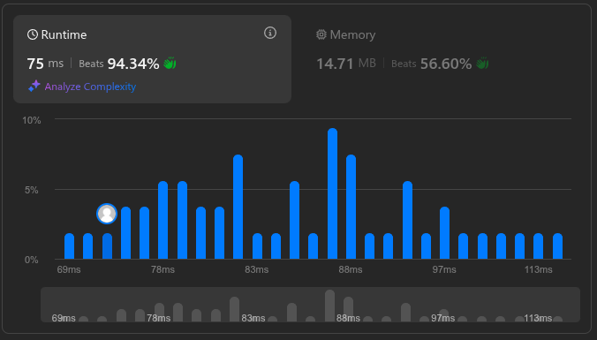

Lab Program 8:
Find Minimum Cost Spanning Tree of a given undirected graph using Prim’s algorithm.

Find Minimum Cost Spanning Tree of a given undirected graph using Kruskal’s algorithm.
Code:
#include <stdio.h>
#include <stdlib.h>

#define MAX 10
#define INF 999

typedef struct {
int u, v, weight;
} Edge;

int parent[MAX], rank[MAX];
Edge edges[MAX * MAX];
int n, m;

void initSet() {
for (int i = 0; i < n; i++) {
parent[i] = i;
rank[i] = 0;
}
}

int find(int i) {
if (i != parent[i]) {
parent[i] = find(parent[i]);
}
return parent[i];
}

void unionSet(int i, int j) {
int root1 = find(i);
int root2 = find(j);

if (root1 != root2) {
if (rank[root1] > rank[root2]) {
parent[root2] = root1;
} else if (rank[root1] < rank[root2]) {
parent[root1] = root2;
} else {
parent[root2] = root1;
rank[root1]++;
}
}
}

int compare(const void *a, const void *b) {
return ((Edge *)a)->weight - ((Edge *)b)->weight;
}

void kruskal() {
int mstWeight = 0;
int edgeCount = 0;

qsort(edges, m, sizeof(Edge), compare);

for (int i = 0; i < m; i++) {
int u = edges[i].u;
int v = edges[i].v;

if (find(u) != find(v)) {
printf("Edge (%d, %d) with weight %d\n", u, v, edges[i].weight);
unionSet(u, v);
mstWeight += edges[i].weight;
edgeCount++;

if (edgeCount == n - 1) {
break;
}
}
}

printf("\nTotal weight of MST: %d\n", mstWeight);
}

int main() {
printf("Enter number of vertices: ");
scanf("%d", &n);
printf("Enter number of edges: ");
scanf("%d", &m);

printf("Enter the edges (u, v, weight):\n");
for (int i = 0; i < m; i++) {
scanf("%d %d %d", &edges[i].u, &edges[i].v, &edges[i].weight);
}

initSet();
kruskal();

return 0;
}
Output:
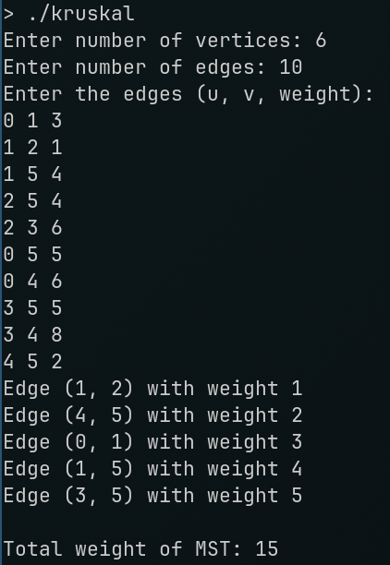

Code:
#include <stdio.h>

int cost[10][10], n, t[10][2], sum = 0;

void prims() {
int i, j, u, v;
int min, source;
int p[10], d[10], s[10];

source = 0;
min = 999;

for (i = 0; i < n; i++) {
d[i] = (cost[source][i] == 0 && i != source) ? 999 : cost[source][i];
s[i] = 0;
p[i] = source;
}

s[source] = 1;
sum = 0;

int k = 0;
for (i = 0; i < n - 1; i++) {
min = 999;
u = -1;

for (j = 0; j < n; j++) {
if (s[j] == 0 && d[j] < min) {
min = d[j];
u = j;
}
}

if (u != -1) {
t[k][0] = u;
t[k][1] = p[u];
k++;

sum += cost[u][p[u]];

s[u] = 1;

for (v = 0; v < n; v++) {
if (s[v] == 0 && cost[u][v] != 0 && cost[u][v] < d[v]) {
d[v] = cost[u][v];
p[v] = u;
}
}
}
}
}

void main() {
int i, j;

printf("Enter n: ");
scanf("%d", &n);

printf("Enter the cost adjacency matrix:\n");
for (i = 0; i < n; i++) {
for (j = 0; j < n; j++) {
scanf("%d", &cost[i][j]);
}
}

prims();

printf("Edges of MST:\n");
for (i = 0; i < n - 1; i++) {
printf("(%d, %d)\n", t[i][0], t[i][1]);
}

printf("\nMinimal Sum: %d\n", sum);
}
Output:
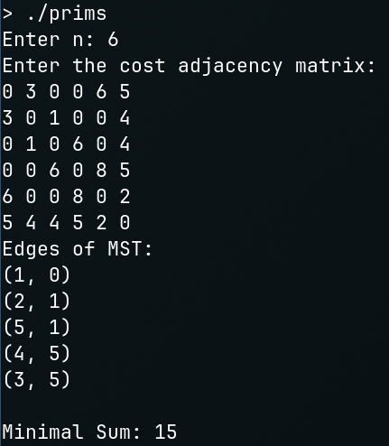
Lab Program 9:
Implement Fractional Knapsack using Greedy technique.
Code:
#include <stdio.h>
#include <stdlib.h>

typedef struct obj {
int v;
int w;
} obj;

int compare(const void *a, const void *b) {
obj *objA = (obj *)a;
obj *objB = (obj *)b;
float ratioA = (float)objA->v / objA->w;
float ratioB = (float)objB->v / objB->w;
if (ratioA > ratioB) {
return -1;
} else if (ratioA < ratioB) {
return 1;
} else {
return 0;
}
}

void fracKnap(obj *arr, int n, int max) {
qsort(arr, n, sizeof(obj), compare);
float *qty = (float *)malloc(n * sizeof(float));
for (int i = 0; i < n; i++) {
qty[i] = 0.0;
}

int i = 0;
for (; i < n; i++) {
if (arr[i].w <= max) {
qty[i] = 1.0;
max -= arr[i].w;
} else {
break;
}
}

if (i < n) {
qty[i] = (float)max / arr[i].w;
max = 0;
}

float val = 0;
for (int i = 0; i < n; i++) {
val += qty[i] * arr[i].v;
printf("Quantity of item %d: %f\n",arr[i].v, qty[i]);
}

printf("\nTotal value of knapsack: %f\n", val);
free(qty);
}

int main() {
int n;
printf("Enter the number of items: ");
scanf("%d", &n);

obj *arr = (obj *)malloc(n * sizeof(obj));

printf("Enter value and weight pairs:\n");
for (int i = 0; i < n; i++) {
scanf("%d %d", &arr[i].v, &arr[i].w);
}

int max;
printf("Enter the maximum weight of the knapsack: ");
scanf("%d", &max);

fracKnap(arr, n, max);
free(arr);

return 0;
}
Output:
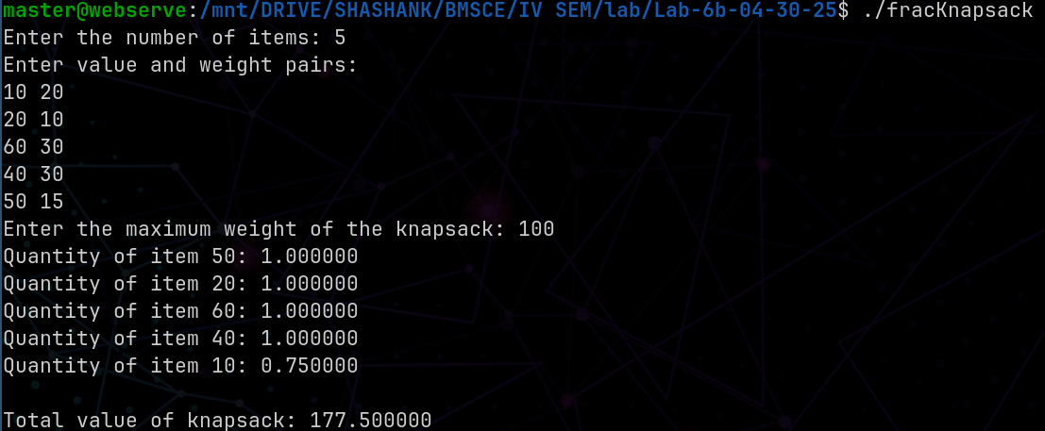

LeetCode Program related to Greedy Technique algorithms.
NON OVERLAPPING INTERVALS
Code:
int compare(const void *a,const void *b)
{
int *intervals_A=*(int**)a;
int *intervals_B=*(int**)b;
return intervals_A[0]-intervals_B[0];
}

int eraseOverlapIntervals(int** intervals, int intervalsSize, int* intervalsColSize)
{
int count=0;

qsort(intervals,intervalsSize,sizeof(int*),compare);

int prev_End=intervals[0][1];
for(int i=1;i<intervalsSize;i++)

if(intervals[i][0]<prev_End)
{
count++;
prev_End=(intervals[i][1]<prev_End)?intervals[i][1]:prev_End;
}
else
{
prev_End=intervals[i][1];
}

return count;

}
Output:
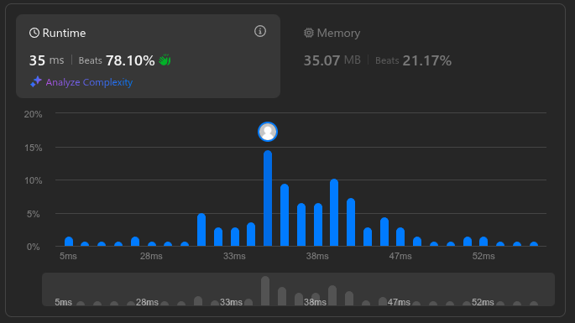

Lab Program 10:
From a given vertex in a weighted connected graph, find shortest paths to other vertices using Dijkstra’s algorithm.
Code:
#include<stdio.h>
void main()
{
int i,j,n,v,k,min,u,c[20][20],s[20],d[20];

printf("\n Enter the no. of vertices : ");
scanf("%d",&n);
printf("\n Enter the cost adjacency matrix : ");
printf("\n Enter 999 for no edge : \n");
for(i=1;i<=n;i++)
{
for(j=1;j<=n;j++)
{
scanf("%d",&c[i][j]);
}
}
printf("\n Enter the source vertex : ");
scanf("%d",&v);
for(i=1;i<=n;i++)
{
s[i]=0;
d[i]=c[v][i];
}
d[v]=0;
s[v]=1;
for(k=2;k<=n;k++)
{
min=999;
for(i=1;i<=n;i++)
{
if((s[i]==0)&&(d[i]<min))
{
min=d[i];
u=i;
}
}
s[u]=1;
for(i=1;i<=n;i++)
{

if(s[i]==0)
{
if(d[i]>(d[u]+c[u][i]))
{
d[i]=d[u]+c[u][i];
}
}

}
}
printf("\n The shortest distance from %d is ",v);
for(i=1;i<=n;i++)
{
printf("\n %d --> %d = %d ",v,i,d[i]);
}
printf("\n");
}
Output:
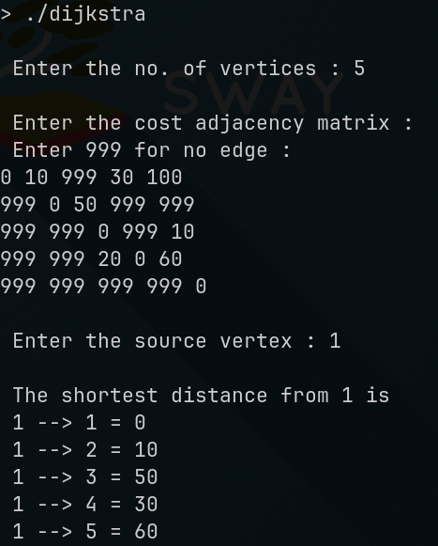

Lab Program 11:
Implement “N-Queens Problem” using Backtracking.
Code:
#include <stdio.h>
#include <stdbool.h>

#define N 4

bool isSafe(int board[], int row, int col) {
for (int i = 0; i < row; i++) {
if (board[i] == col ||
board[i] - i == col - row ||
board[i] + i == col + row) {
return false;
}
}
return true;
}

void printSolution(int board[]) {
for (int i = 0; i < N; i++) {
for (int j = 0; j < N; j++) {
if (board[i] == j) {
printf("Q ");
} else {
printf(". ");
}
}
printf("\n");
}
printf("\n");
}

bool solveNQueens(int board[], int row) {
if (row == N) {
printSolution(board);
return true;
}

bool res = false;
for (int col = 0; col < N; col++) {
if (isSafe(board, row, col)) {
board[row] = col;
res = solveNQueens(board, row + 1) || res;
board[row] = -1;
}
}
return res;
}

int main() {
int board[N];
for (int i = 0; i < N; i++) {
board[i] = -1;
}

if (!solveNQueens(board, 0)) {
printf("No solution exists.\n");
}

return 0;
}
Output:
